Novuss4everyone
Regulations of competitions

Goals and objectives
  - Popularization of Novuss in the world as a healthy way of life and an interesting sport, sports accessible to people with disabilities and without.
  - Consolidation of Novuss games and sports in the international community.
  - Increasing sportsmanship among Novuss players.

Time and place
  - Place: online platform (ZOOM or similar)
  - Time: 18-27 June 2021
  - Applications: 30.05.2021 , 12:00 CEST

Organization committee of the competitions
  - On behalf of TAFISA following Novuss sport organizations will organize and conduct the competitions:
    - Novuss Sport ohne Barrieren e.V., Germany
    - Stowarzyszenie Polska, Poland
    - NovussPool&TableGames BLACK HORSES, Great Britain
  - Organization Committee:
    - Coordinator and main referee:
Kaspars Paegle (GER)
E-Mail: paeglek@gmail.com,
Tel.+49 176 81617151
    - Referees:
Maciej Kunc (POL)
Andris Sudmalis (GBR)

Events and Participants
  - To be eligible to participate in the competition’s players must be at least 18 years old and must represent the national Novuss sport federation and comply to tournament organization rules and tournament regulations.
  - Players can play in the following disciplines:
☒individual, 8 pucks

Applications
  - Latest submission date: 30.05.2021, 12:00 CEST
  - Applications must be sent to:
E-Mail: paeglek@gmail.com (Kaspars Paegle) or using application form on our homepage:
https://www.novuss-sport.org

Novuss4everyone

Live broadcasting and filming
  - By participating in this event, you consent to be filmed and/or otherwise recorded and broadcasted (for example Facebook, YouTube, websites). Your participation constitutes your consent to such filming and/or recording.

Registration fee
  - The amount of the registration fee for the participants: 5,00 €
  - Payment of registration fee must be in € - EUR and not later than 30.05.2021.
Novuss Sport ohne Barrieren
Sparkasse Erlangen
IBAN: DE61763500000060065762
BIC: BYLADEM1ERH
  - The participation fee will be used for the prize fund.

Organization of the competition and determination of the winner
  - Competition will be organised in two stages:
    - Group stage (qualification) - the competitors will be divided into multiple groups, which play separate round-robins in parallel. The number of groups and the number of participants in a group depends on the total number of participants. Top competitors in each group will qualify for the knockout stage (8 players in total).
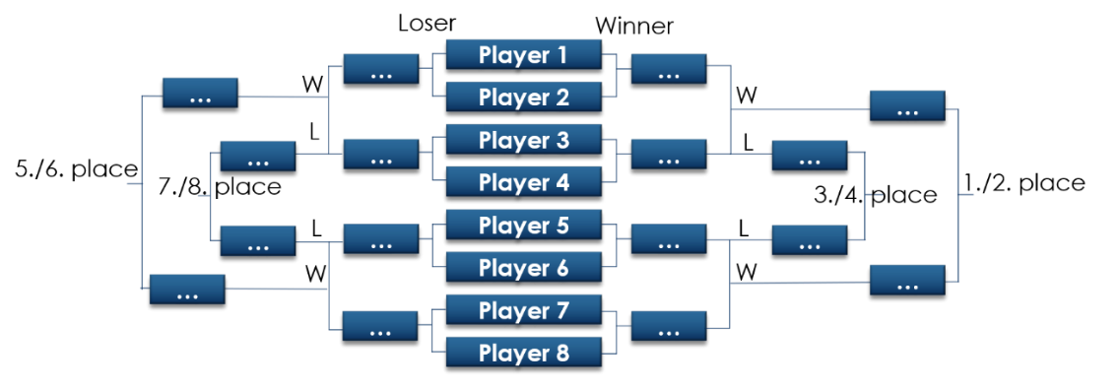
    - Knockout stage - played up to 4 winning sets (4:0; 4:1; 4:2; 4:3;) according to the format below:
  - Rules for the group stage:
    - In each round, the participants of the competition play up to 4 winning sets (4:0; 4:1; 4:2; 4:3;).
    - Procedure for awarding points: 2 = win, 0 = loss.
    - The participant with the most points wins. In case of an equal number of points, the places are determined as follows:
      - If two participants have the same number of points, then the participant with the best mutual result has the higher place.
      - If three participants have the same number of points, then the ratio of lost and won sets of all games in the group is evaluated.

Novuss4everyone

Prizes
  - Prizes from the prize fund will be organized for the first three places.
- Preliminary program
  - Group stage: 19. - 24. June 2021 - reserved times for groups.
20. June 17:00 and 21. – 24. June 19:00
  - Knockout stage: 26. June 2021, start at 17:00.
Considered time zone CEST (Central European Summer Time)
Example: 9:00 (CEST) = 8:00 (GBR) = 9:00 (GER, POL) = 10:00 (LAT, EST, RUS, UKR)

